UNITED STATES
SECURITIES AND EXCHANGE COMMISSION
WASHINGTON, D.C. 20549

FORM |  |  | 8-K

CURRENT REPORT

Pursuant to Section 13 or 15(d) of the SECURITIES EXCHANGE ACT OF 1934
_______________________

Date of Report (Date of earliest event reported):

October 1, 2026

McCormick & Company, Inc.
(Exact name of registrant as specified in its charter)

Maryland |  |  | 001-14920 |  |  | 52-0408290
(State or other jurisdiction |  |  | (Commission |  |  | (IRS Employer
of incorporation) |  |  | File Number) |  |  | Identification No.)
24 Schilling Road |  |  | Suite 1
Hunt Valley |  |  | MD |  |  | 21031
(Address of principal executive offices) |  |  |  |  |  | (Zip Code)

Registrant's telephone number, including area code:
(410) |  |  | 771-7301

Check the appropriate box below if the Form 8-K filing is intended to simultaneously satisfy the filing obligation of the registrant under any of the following provisions (see General Instruction A.2. below):

☐ Written communications pursuant to Rule 425 under the Securities Act (17 CFR 230.425)

☐ Soliciting material pursuant to Rule 14a-12 under the Exchange Act (17 CFR 240.14a-12)

☐ Pre-commencement communications pursuant to Rule 14d-2(b) under the Exchange Act (17 CFR 240.14d-2(b).

☐ Pre-commencement communications pursuant to Rule 13e-4(c) under the Exchange Act (17 CFR 240.13e-4(c).

Securities registered pursuant to Section 12(b) of the Act:

Title of each class |  |  | Trading Symbol(s) |  |  | Name of each exchange on which registered
Common Stock |  |  | MKC.V |  |  | New York Stock Exchange
Common Stock Non-Voting |  |  | MKC |  |  | New York Stock Exchange

Indicate by check mark whether the Registrant is an emerging growth company as defined in Rule 405 of the Securities Act of 1933 (§230.405 of this chapter) or Rule 12b-2 of the Securities Exchange Act of 1934 (§240.12b-2 of this chapter).

Emerging growth company ☐

If an emerging growth company, indicate by check mark if the Registrant has elected not to use the extended transition period for complying with any new or revised financial accounting standards provided pursuant to Section 13(a) of the Exchange Act. ☐

Item 2.02 Results of Operations and Financial Condition

On October 1, 2026, the Registrant issued a press release and held a conference call with analysts to report on the results of operations for the third quarter for fiscal year 2026, which ended August 31, 2026.

Furnished with this Form 8-K as Exhibit 99.1 is a copy of the press release labeled "McCormick Reports Solid Third Quarter Performance and Reaffirms 2026 Outlook," which includes an unaudited Consolidated Income Statement for the three and nine months ended August 31, 2026, an unaudited Consolidated Balance Sheet of the Registrant as of August 31, 2026, and an unaudited Consolidated Cash Flow Statement for the nine months ended August 31, 2026.

Item 9.01: Financial Statements and Exhibits
(d) Exhibits.

Exhibit Number |  |  | Description
99.1 |  |  | Press Release
104 |  |  | Cover Page Interactive Data File (the cover page XBRL tags are embedded within the Inline XBRL document).

Pursuant to the requirements of the Securities Exchange Act of 1934, the Registrant has duly caused this report to be signed on its behalf by the undersigned hereunto duly authorized.

 |  |  | McCORMICK & COMPANY, INCORPORATED
Date: October 1, 2026 |  |  | By: |  |  |  |  |  | /s/ Jeffery D. Schwartz
 |  |  |  |  |  |  |  |  | Jeffery D. Schwartz
 |  |  |  |  |  |  |  |  | Vice President, General Counsel & Secretary

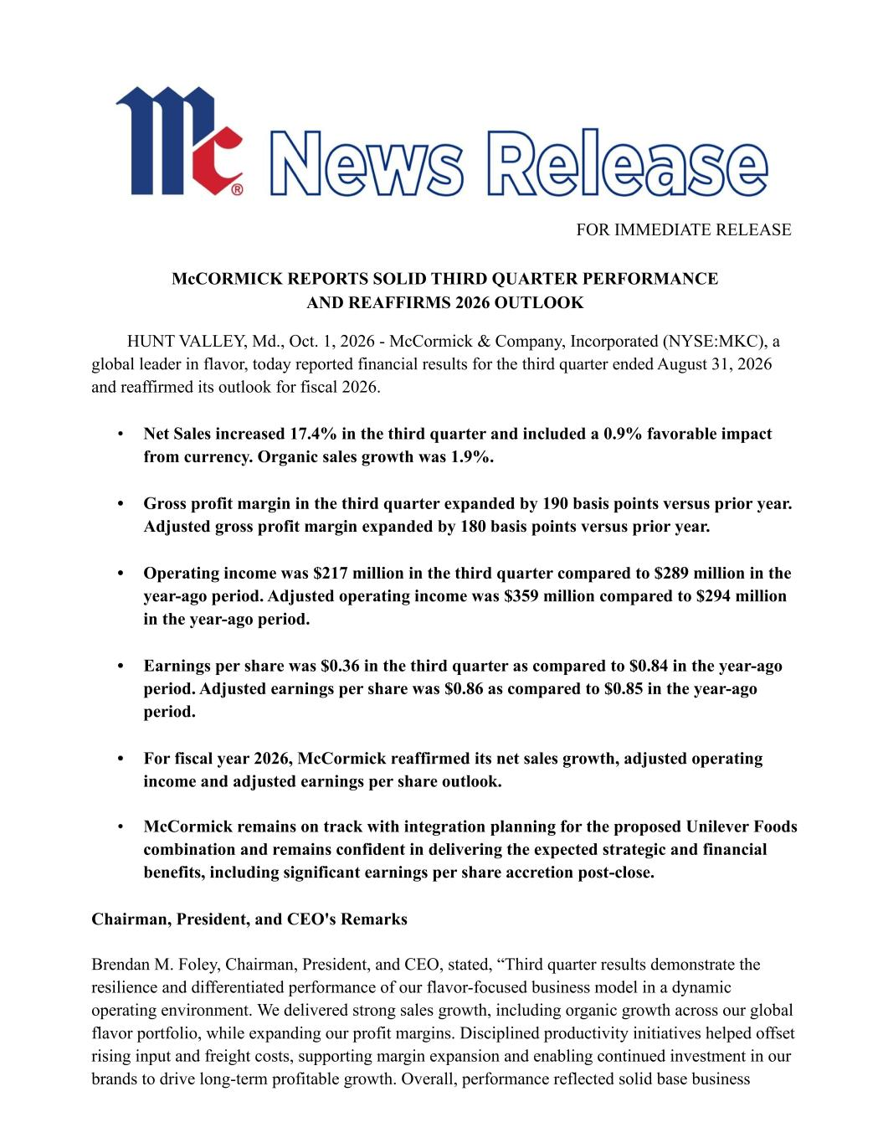

FOR IMMEDIATE RELEASE McCORMICK REPORTS SOLID THIRD QUARTER PERFORMANCE AND REAFFIRMS 2026 OUTLOOK HUNT VALLEY, Md., Oct. 1, 2026 - McCormick & Company, Incorporated (NYSE:MKC), a global leader in flavor, today reported financial results for the third quarter ended August 31, 2026 and reaffirmed its outlook for fiscal 2026. • Net Sales increased 17.4% in the third quarter and included a 0.9% favorable impact from currency. Organic sales growth was 1.9%. • Gross profit margin in the third quarter expanded by 190 basis points versus prior year. Adjusted gross profit margin expanded by 180 basis points versus prior year. • Operating income was $217 million in the third quarter compared to $289 million in the year-ago period. Adjusted operating income was $359 million compared to $294 million in the year-ago period. • Earnings per share was $0.36 in the third quarter as compared to $0.84 in the year-ago period. Adjusted earnings per share was $0.86 as compared to $0.85 in the year-ago period. • For fiscal year 2026, McCormick reaffirmed its net sales growth, adjusted operating income and adjusted earnings per share outlook. • McCormick remains on track with integration planning for the proposed Unilever Foods combination and remains confident in delivering the expected strategic and financial benefits, including significant earnings per share accretion post-close. Chairman, President, and CEO's Remarks Brendan M. Foley, Chairman, President, and CEO, stated, “Third quarter results demonstrate the resilience and differentiated performance of our flavor-focused business model in a dynamic operating environment. We delivered strong sales growth, including organic growth across our global flavor portfolio, while expanding our profit margins. Disciplined productivity initiatives helped offset rising input and freight costs, supporting margin expansion and enabling continued investment in our brands to drive long-term profitable growth. Overall, performance reflected solid base business

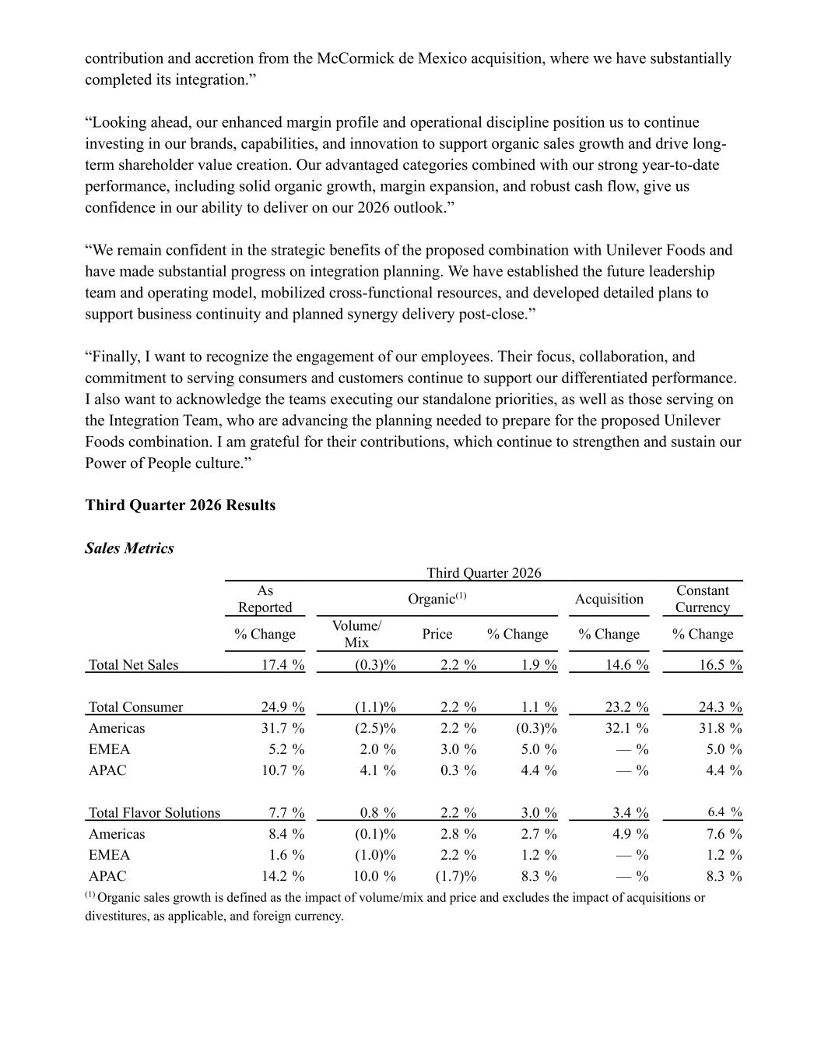
contribution and accretion from the McCormick de Mexico acquisition, where we have substantially completed its integration.” “Looking ahead, our enhanced margin profile and operational discipline position us to continue investing in our brands, capabilities, and innovation to support organic sales growth and drive long- term shareholder value creation. Our advantaged categories combined with our strong year-to-date performance, including solid organic growth, margin expansion, and robust cash flow, give us confidence in our ability to deliver on our 2026 outlook.” “We remain confident in the strategic benefits of the proposed combination with Unilever Foods and have made substantial progress on integration planning. We have established the future leadership team and operating model, mobilized cross-functional resources, and developed detailed plans to support business continuity and planned synergy delivery post-close.” “Finally, I want to recognize the engagement of our employees. Their focus, collaboration, and commitment to serving consumers and customers continue to support our differentiated performance. I also want to acknowledge the teams executing our standalone priorities, as well as those serving on the Integration Team, who are advancing the planning needed to prepare for the proposed Unilever Foods combination. I am grateful for their contributions, which continue to strengthen and sustain our Power of People culture.” Third Quarter 2026 Results Sales Metrics Third Quarter 2026 As Reported Organic(1) Acquisition Constant Currency % Change Volume/ Mix Price % Change % Change % Change Total Net Sales 17.4 % (0.3) % 2.2 % 1.9 % 14.6 % 16.5 % Total Consumer 24.9 % (1.1) % 2.2 % 1.1 % 23.2 % 24.3 % Americas 31.7 % (2.5) % 2.2 % (0.3) % 32.1 % 31.8 % EMEA 5.2 % 2.0 % 3.0 % 5.0 % — % 5.0 % APAC 10.7 % 4.1 % 0.3 % 4.4 % — % 4.4 % Total Flavor Solutions 7.7 % 0.8 % 2.2 % 3.0 % 3.4 % 6.4 % Americas 8.4 % (0.1) % 2.8 % 2.7 % 4.9 % 7.6 % EMEA 1.6 % (1.0) % 2.2 % 1.2 % — % 1.2 % APAC 14.2 % 10.0 % (1.7) % 8.3 % — % 8.3 % (1) Organic sales growth is defined as the impact of volume/mix and price and excludes the impact of acquisitions or divestitures, as applicable, and foreign currency.

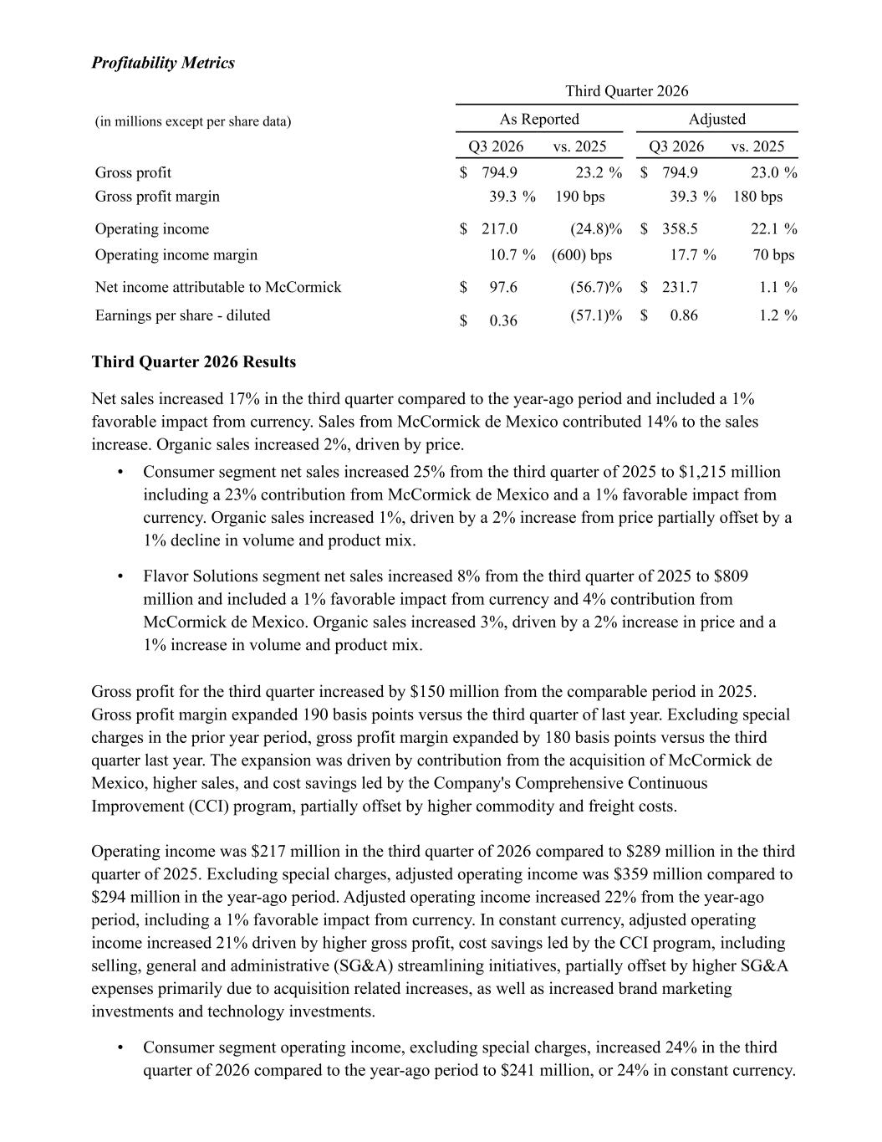
Profitability Metrics Third Quarter 2026 (in millions except per share data) As Reported Adjusted Q3 2026 vs. 2025 Q3 2026 vs. 2025 Gross profit $ 794.9 23.2 % $ 794.9 23.0 % Gross profit margin 39.3 % 190 bps 39.3 % 180 bps Operating income $ 217.0 (24.8) % $ 358.5 22.1 % Operating income margin 10.7 % (600) bps 17.7 % 70 bps Net income attributable to McCormick $ 97.6 (56.7) % $ 231.7 1.1 % Earnings per share - diluted $ 0.36 (57.1) % $ 0.86 1.2 % Third Quarter 2026 Results Net sales increased 17% in the third quarter compared to the year-ago period and included a 1% favorable impact from currency. Sales from McCormick de Mexico contributed 14% to the sales increase. Organic sales increased 2%, driven by price. • Consumer segment net sales increased 25% from the third quarter of 2025 to $1,215 million including a 23% contribution from McCormick de Mexico and a 1% favorable impact from currency. Organic sales increased 1%, driven by a 2% increase from price partially offset by a 1% decline in volume and product mix. • Flavor Solutions segment net sales increased 8% from the third quarter of 2025 to $809 million and included a 1% favorable impact from currency and 4% contribution from McCormick de Mexico. Organic sales increased 3%, driven by a 2% increase in price and a 1% increase in volume and product mix. Gross profit for the third quarter increased by $150 million from the comparable period in 2025. Gross profit margin expanded 190 basis points versus the third quarter of last year. Excluding special charges in the prior year period, gross profit margin expanded by 180 basis points versus the third quarter last year. The expansion was driven by contribution from the acquisition of McCormick de Mexico, higher sales, and cost savings led by the Company's Comprehensive Continuous Improvement (CCI) program, partially offset by higher commodity and freight costs. Operating income was $217 million in the third quarter of 2026 compared to $289 million in the third quarter of 2025. Excluding special charges, adjusted operating income was $359 million compared to $294 million in the year-ago period. Adjusted operating income increased 22% from the year-ago period, including a 1% favorable impact from currency. In constant currency, adjusted operating income increased 21% driven by higher gross profit, cost savings led by the CCI program, including selling, general and administrative (SG&A) streamlining initiatives, partially offset by higher SG&A expenses primarily due to acquisition related increases, as well as increased brand marketing investments and technology investments. • Consumer segment operating income, excluding special charges, increased 24% in the third quarter of 2026 compared to the year-ago period to $241 million, or 24% in constant currency.

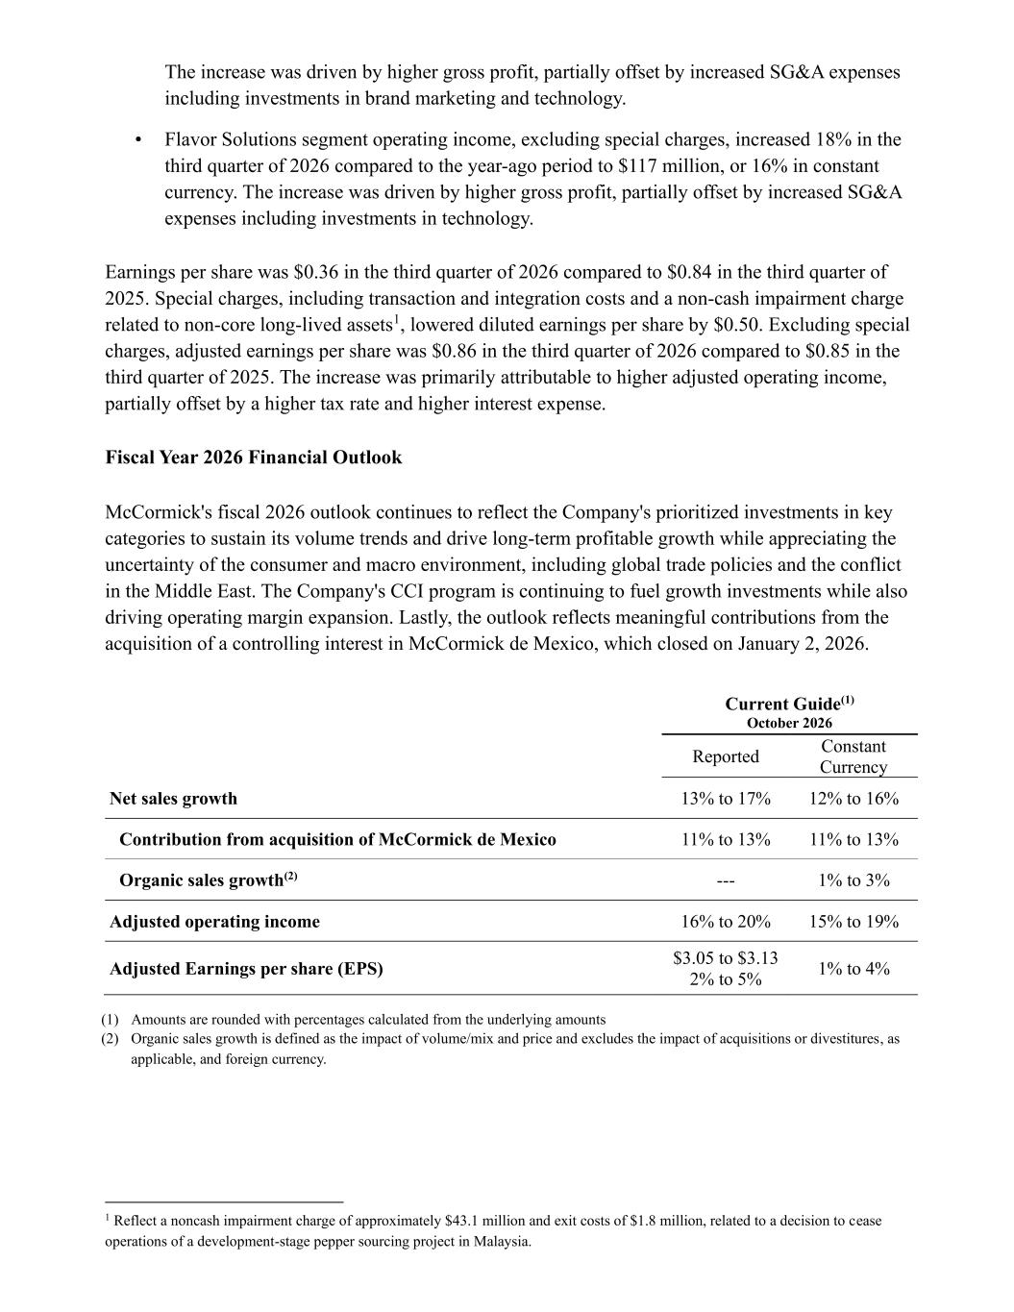
The increase was driven by higher gross profit, partially offset by increased SG&A expenses including investments in brand marketing and technology. • Flavor Solutions segment operating income, excluding special charges, increased 18% in the third quarter of 2026 compared to the year-ago period to $117 million, or 16% in constant currency. The increase was driven by higher gross profit, partially offset by increased SG&A expenses including investments in technology. Earnings per share was $0.36 in the third quarter of 2026 compared to $0.84 in the third quarter of 2025. Special charges, including transaction and integration costs and a non-cash impairment charge related to non-core long-lived assets1, lowered diluted earnings per share by $0.50. Excluding special charges, adjusted earnings per share was $0.86 in the third quarter of 2026 compared to $0.85 in the third quarter of 2025. The increase was primarily attributable to higher adjusted operating income, partially offset by a higher tax rate and higher interest expense. Fiscal Year 2026 Financial Outlook McCormick's fiscal 2026 outlook continues to reflect the Company's prioritized investments in key categories to sustain its volume trends and drive long-term profitable growth while appreciating the uncertainty of the consumer and macro environment, including global trade policies and the conflict in the Middle East. The Company's CCI program is continuing to fuel growth investments while also driving operating margin expansion. Lastly, the outlook reflects meaningful contributions from the acquisition of a controlling interest in McCormick de Mexico, which closed on January 2, 2026. Current Guide(1) October 2026 Reported Constant Currency Net sales growth 13% to 17% 12% to 16% Contribution from acquisition of McCormick de Mexico 11% to 13% 11% to 13% Organic sales growth(2) --- 1% to 3% Adjusted operating income 16% to 20% 15% to 19% Adjusted Earnings per share (EPS) $3.05 to $3.13 2% to 5% 1% to 4% (1) Amounts are rounded with percentages calculated from the underlying amounts (2) Organic sales growth is defined as the impact of volume/mix and price and excludes the impact of acquisitions or divestitures, as applicable, and foreign currency. 1 Reflect a noncash impairment charge of approximately $43.1 million and exit costs of $1.8 million, related to a decision to cease operations of a development-stage pepper sourcing project in Malaysia.

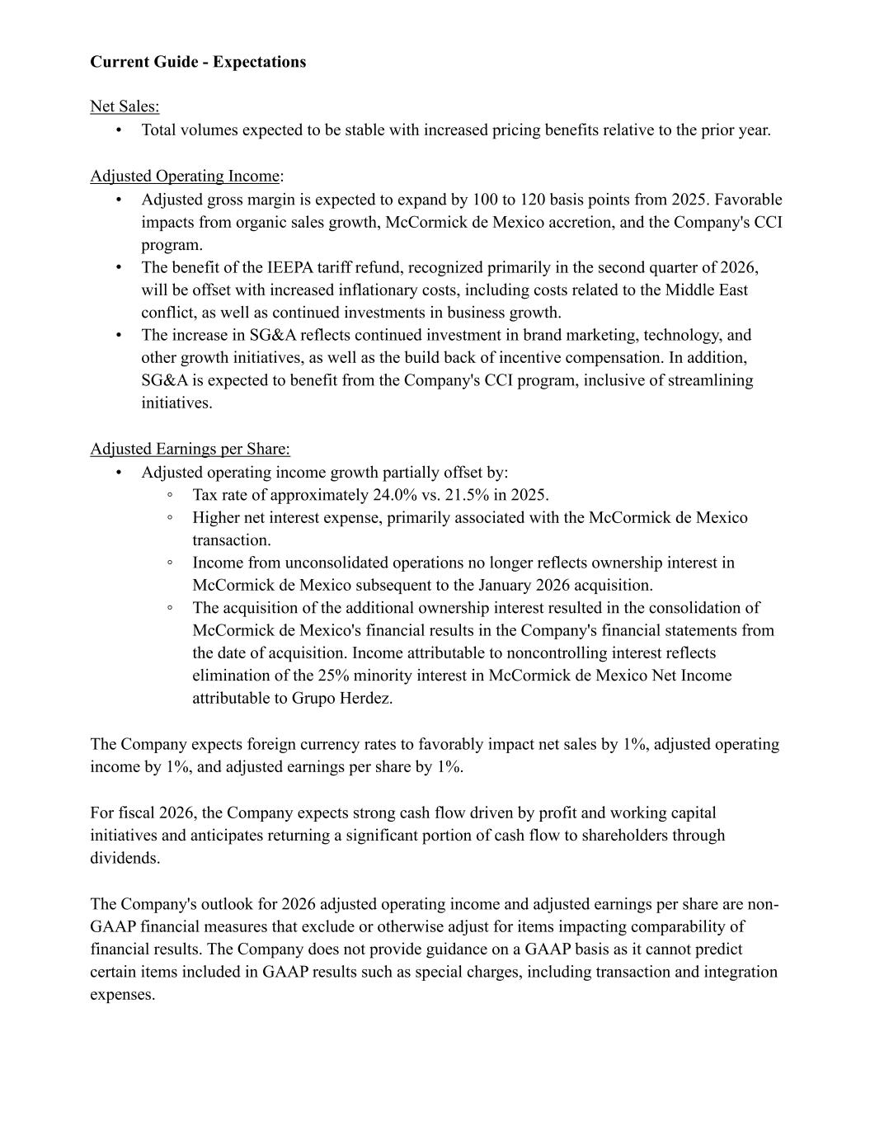
Current Guide - Expectations Net Sales: • Total volumes expected to be stable with increased pricing benefits relative to the prior year. Adjusted Operating Income: • Adjusted gross margin is expected to expand by 100 to 120 basis points from 2025. Favorable impacts from organic sales growth, McCormick de Mexico accretion, and the Company's CCI program. • The benefit of the IEEPA tariff refund, recognized primarily in the second quarter of 2026, will be offset with increased inflationary costs, including costs related to the Middle East conflict, as well as continued investments in business growth. • The increase in SG&A reflects continued investment in brand marketing, technology, and other growth initiatives, as well as the build back of incentive compensation. In addition, SG&A is expected to benefit from the Company's CCI program, inclusive of streamlining initiatives. Adjusted Earnings per Share: • Adjusted operating income growth partially offset by: ◦ Tax rate of approximately 24.0% vs. 21.5% in 2025. ◦ Higher net interest expense, primarily associated with the McCormick de Mexico transaction. ◦ Income from unconsolidated operations no longer reflects ownership interest in McCormick de Mexico subsequent to the January 2026 acquisition. ◦ The acquisition of the additional ownership interest resulted in the consolidation of McCormick de Mexico's financial results in the Company's financial statements from the date of acquisition. Income attributable to noncontrolling interest reflects elimination of the 25% minority interest in McCormick de Mexico Net Income attributable to Grupo Herdez. The Company expects foreign currency rates to favorably impact net sales by 1%, adjusted operating income by 1%, and adjusted earnings per share by 1%. For fiscal 2026, the Company expects strong cash flow driven by profit and working capital initiatives and anticipates returning a significant portion of cash flow to shareholders through dividends. The Company's outlook for 2026 adjusted operating income and adjusted earnings per share are non- GAAP financial measures that exclude or otherwise adjust for items impacting comparability of financial results. The Company does not provide guidance on a GAAP basis as it cannot predict certain items included in GAAP results such as special charges, including transaction and integration expenses.

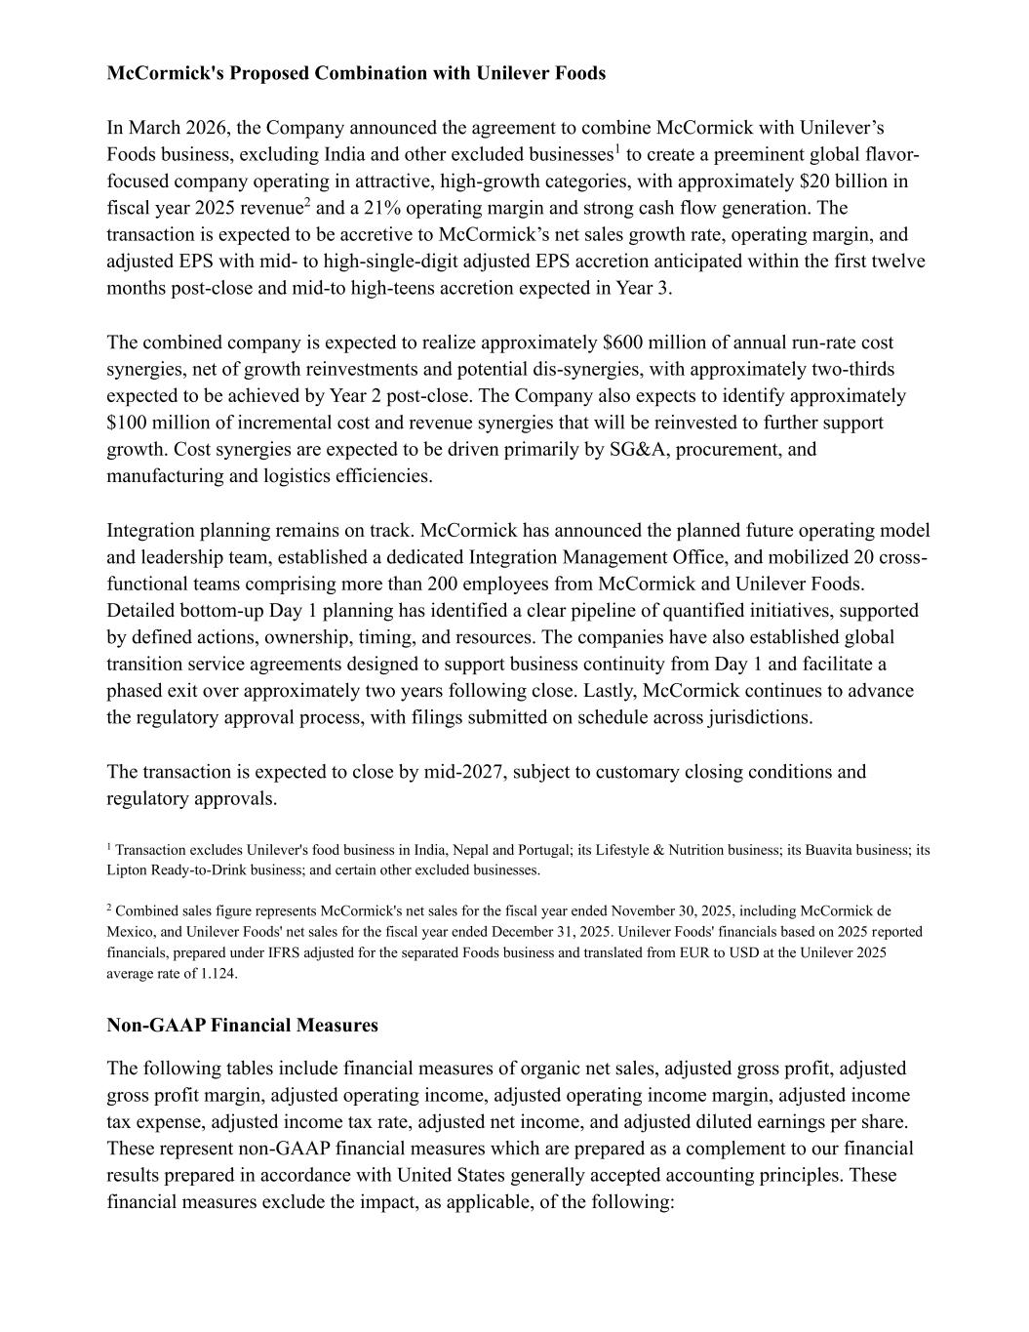
McCormick's Proposed Combination with Unilever Foods In March 2026, the Company announced the agreement to combine McCormick with Unilever’s Foods business, excluding India and other excluded businesses1 to create a preeminent global flavor- focused company operating in attractive, high-growth categories, with approximately $20 billion in fiscal year 2025 revenue2 and a 21% operating margin and strong cash flow generation. The transaction is expected to be accretive to McCormick’s net sales growth rate, operating margin, and adjusted EPS with mid- to high-single-digit adjusted EPS accretion anticipated within the first twelve months post-close and mid-to high-teens accretion expected in Year 3. The combined company is expected to realize approximately $600 million of annual run-rate cost synergies, net of growth reinvestments and potential dis-synergies, with approximately two-thirds expected to be achieved by Year 2 post-close. The Company also expects to identify approximately $100 million of incremental cost and revenue synergies that will be reinvested to further support growth. Cost synergies are expected to be driven primarily by SG&A, procurement, and manufacturing and logistics efficiencies. Integration planning remains on track. McCormick has announced the planned future operating model and leadership team, established a dedicated Integration Management Office, and mobilized 20 cross- functional teams comprising more than 200 employees from McCormick and Unilever Foods. Detailed bottom-up Day 1 planning has identified a clear pipeline of quantified initiatives, supported by defined actions, ownership, timing, and resources. The companies have also established global transition service agreements designed to support business continuity from Day 1 and facilitate a phased exit over approximately two years following close. Lastly, McCormick continues to advance the regulatory approval process, with filings submitted on schedule across jurisdictions. The transaction is expected to close by mid-2027, subject to customary closing conditions and regulatory approvals. 1 Transaction excludes Unilever's food business in India, Nepal and Portugal; its Lifestyle & Nutrition business; its Buavita business; its Lipton Ready-to-Drink business; and certain other excluded businesses. 2 Combined sales figure represents McCormick's net sales for the fiscal year ended November 30, 2025, including McCormick de Mexico, and Unilever Foods' net sales for the fiscal year ended December 31, 2025. Unilever Foods' financials based on 2025 reported financials, prepared under IFRS adjusted for the separated Foods business and translated from EUR to USD at the Unilever 2025 average rate of 1.124. Non-GAAP Financial Measures The following tables include financial measures of organic net sales, adjusted gross profit, adjusted gross profit margin, adjusted operating income, adjusted operating income margin, adjusted income tax expense, adjusted income tax rate, adjusted net income, and adjusted diluted earnings per share. These represent non-GAAP financial measures which are prepared as a complement to our financial results prepared in accordance with United States generally accepted accounting principles. These financial measures exclude the impact, as applicable, of the following:

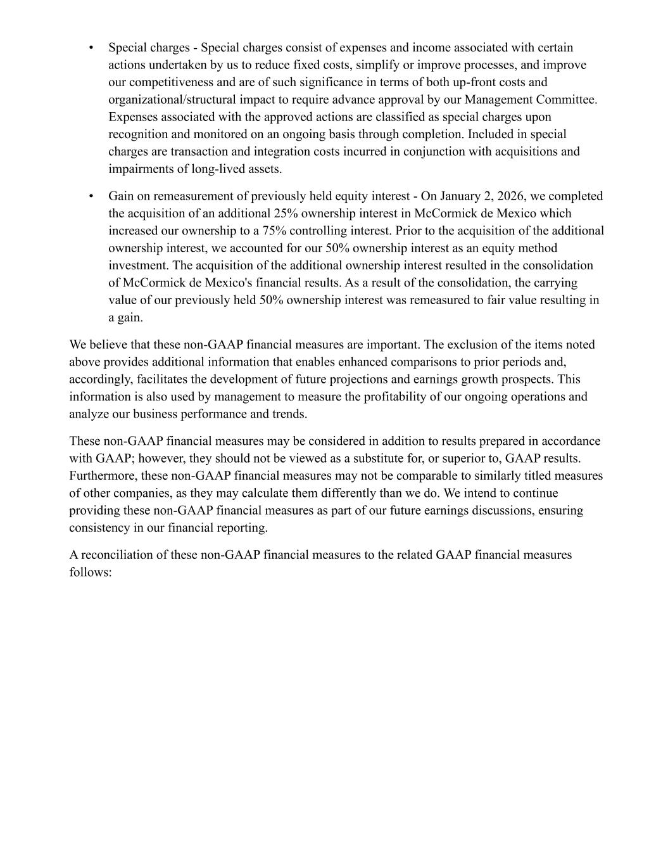
• Special charges - Special charges consist of expenses and income associated with certain actions undertaken by us to reduce fixed costs, simplify or improve processes, and improve our competitiveness and are of such significance in terms of both up-front costs and organizational/structural impact to require advance approval by our Management Committee. Expenses associated with the approved actions are classified as special charges upon recognition and monitored on an ongoing basis through completion. Included in special charges are transaction and integration costs incurred in conjunction with acquisitions and impairments of long-lived assets. • Gain on remeasurement of previously held equity interest - On January 2, 2026, we completed the acquisition of an additional 25% ownership interest in McCormick de Mexico which increased our ownership to a 75% controlling interest. Prior to the acquisition of the additional ownership interest, we accounted for our 50% ownership interest as an equity method investment. The acquisition of the additional ownership interest resulted in the consolidation of McCormick de Mexico's financial results. As a result of the consolidation, the carrying value of our previously held 50% ownership interest was remeasured to fair value resulting in a gain. We believe that these non-GAAP financial measures are important. The exclusion of the items noted above provides additional information that enables enhanced comparisons to prior periods and, accordingly, facilitates the development of future projections and earnings growth prospects. This information is also used by management to measure the profitability of our ongoing operations and analyze our business performance and trends. These non-GAAP financial measures may be considered in addition to results prepared in accordance with GAAP; however, they should not be viewed as a substitute for, or superior to, GAAP results. Furthermore, these non-GAAP financial measures may not be comparable to similarly titled measures of other companies, as they may calculate them differently than we do. We intend to continue providing these non-GAAP financial measures as part of our future earnings discussions, ensuring consistency in our financial reporting. A reconciliation of these non-GAAP financial measures to the related GAAP financial measures follows:

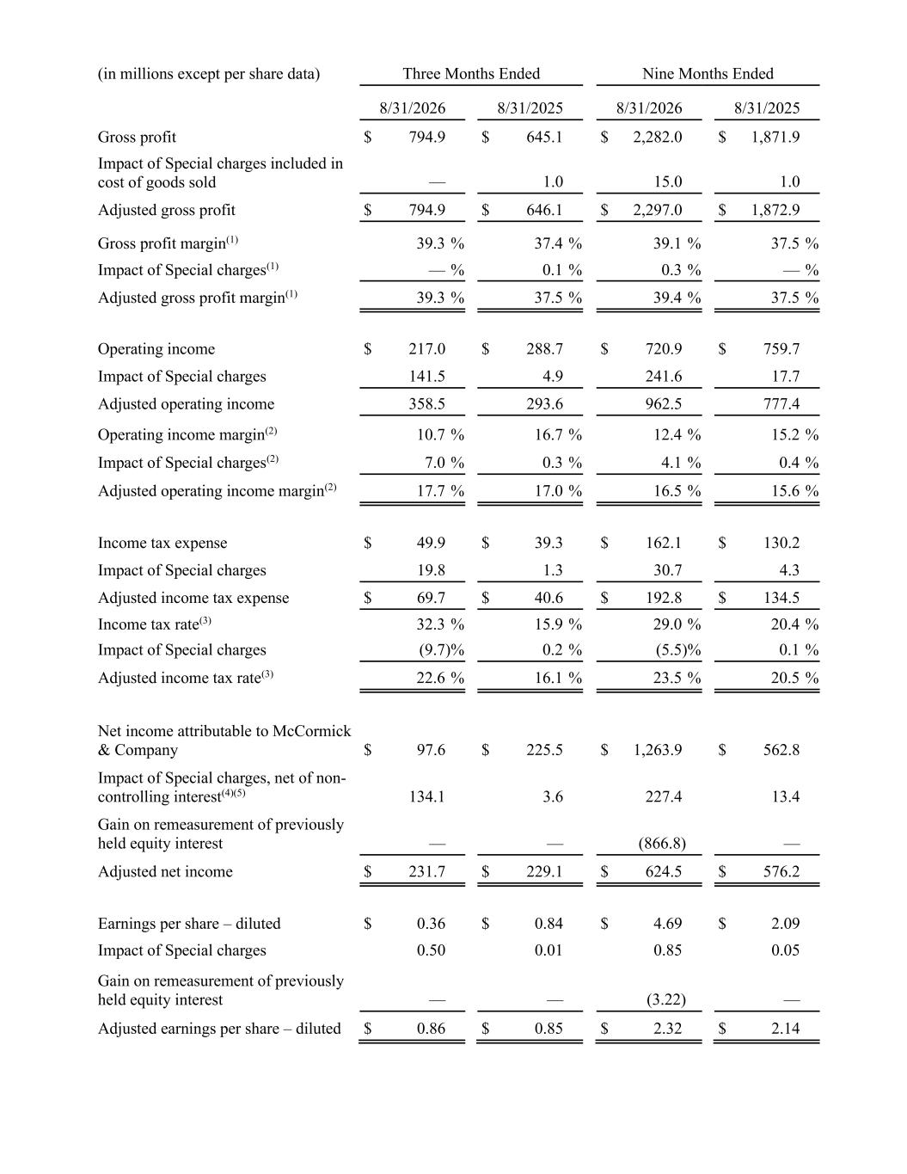
(in millions except per share data) Three Months Ended Nine Months Ended 8/31/2026 8/31/2025 8/31/2026 8/31/2025 Gross profit $ 794.9 $ 645.1 $ 2,282.0 $ 1,871.9 Impact of Special charges included in cost of goods sold — 1.0 15.0 1.0 Adjusted gross profit $ 794.9 $ 646.1 $ 2,297.0 $ 1,872.9 Gross profit margin(1) 39.3 % 37.4 % 39.1 % 37.5 % Impact of Special charges(1) — % 0.1 % 0.3 % — % Adjusted gross profit margin(1) 39.3 % 37.5 % 39.4 % 37.5 % Operating income $ 217.0 $ 288.7 $ 720.9 $ 759.7 Impact of Special charges 141.5 4.9 241.6 17.7 Adjusted operating income 358.5 293.6 962.5 777.4 Operating income margin(2) 10.7 % 16.7 % 12.4 % 15.2 % Impact of Special charges(2) 7.0 % 0.3 % 4.1 % 0.4 % Adjusted operating income margin(2) 17.7 % 17.0 % 16.5 % 15.6 % Income tax expense $ 49.9 $ 39.3 $ 162.1 $ 130.2 Impact of Special charges 19.8 1.3 30.7 4.3 Adjusted income tax expense $ 69.7 $ 40.6 $ 192.8 $ 134.5 Income tax rate(3) 32.3 % 15.9 % 29.0 % 20.4 % Impact of Special charges (9.7) % 0.2 % (5.5) % 0.1 % Adjusted income tax rate(3) 22.6 % 16.1 % 23.5 % 20.5 % Net income attributable to McCormick & Company $ 97.6 $ 225.5 $ 1,263.9 $ 562.8 Impact of Special charges, net of non- controlling interest(4)(5) 134.1 3.6 227.4 13.4 Gain on remeasurement of previously held equity interest — — (866.8) — Adjusted net income $ 231.7 $ 229.1 $ 624.5 $ 576.2 Earnings per share – diluted $ 0.36 $ 0.84 $ 4.69 $ 2.09 Impact of Special charges 0.50 0.01 0.85 0.05 Gain on remeasurement of previously held equity interest — — (3.22) — Adjusted earnings per share – diluted $ 0.86 $ 0.85 $ 2.32 $ 2.14

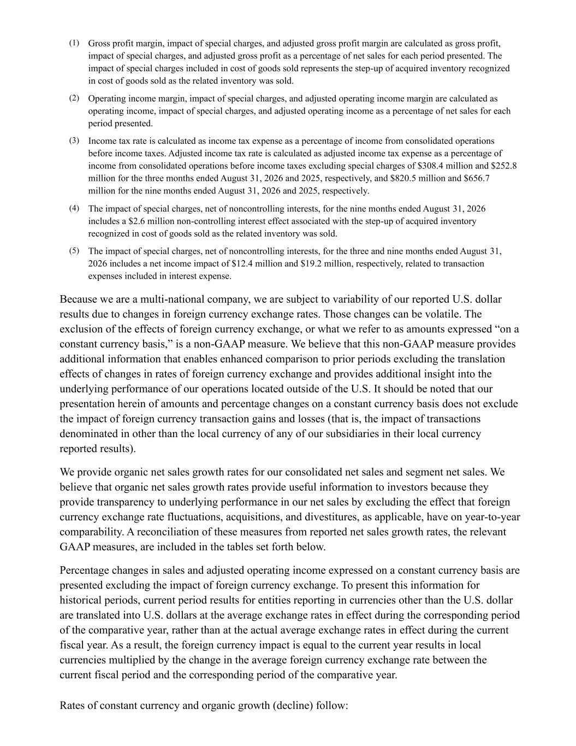
(1) Gross profit margin, impact of special charges, and adjusted gross profit margin are calculated as gross profit, impact of special charges, and adjusted gross profit as a percentage of net sales for each period presented. The impact of special charges included in cost of goods sold represents the step-up of acquired inventory recognized in cost of goods sold as the related inventory was sold. (2) Operating income margin, impact of special charges, and adjusted operating income margin are calculated as operating income, impact of special charges, and adjusted operating income as a percentage of net sales for each period presented. (3) Income tax rate is calculated as income tax expense as a percentage of income from consolidated operations before income taxes. Adjusted income tax rate is calculated as adjusted income tax expense as a percentage of income from consolidated operations before income taxes excluding special charges of $308.4 million and $252.8 million for the three months ended August 31, 2026 and 2025, respectively, and $820.5 million and $656.7 million for the nine months ended August 31, 2026 and 2025, respectively. (4) The impact of special charges, net of noncontrolling interests, for the nine months ended August 31, 2026 includes a $2.6 million non-controlling interest effect associated with the step-up of acquired inventory recognized in cost of goods sold as the related inventory was sold. (5) The impact of special charges, net of noncontrolling interests, for the three and nine months ended August 31, 2026 includes a net income impact of $12.4 million and $19.2 million, respectively, related to transaction expenses included in interest expense. Because we are a multi-national company, we are subject to variability of our reported U.S. dollar results due to changes in foreign currency exchange rates. Those changes can be volatile. The exclusion of the effects of foreign currency exchange, or what we refer to as amounts expressed “on a constant currency basis,” is a non-GAAP measure. We believe that this non-GAAP measure provides additional information that enables enhanced comparison to prior periods excluding the translation effects of changes in rates of foreign currency exchange and provides additional insight into the underlying performance of our operations located outside of the U.S. It should be noted that our presentation herein of amounts and percentage changes on a constant currency basis does not exclude the impact of foreign currency transaction gains and losses (that is, the impact of transactions denominated in other than the local currency of any of our subsidiaries in their local currency reported results). We provide organic net sales growth rates for our consolidated net sales and segment net sales. We believe that organic net sales growth rates provide useful information to investors because they provide transparency to underlying performance in our net sales by excluding the effect that foreign currency exchange rate fluctuations, acquisitions, and divestitures, as applicable, have on year-to-year comparability. A reconciliation of these measures from reported net sales growth rates, the relevant GAAP measures, are included in the tables set forth below. Percentage changes in sales and adjusted operating income expressed on a constant currency basis are presented excluding the impact of foreign currency exchange. To present this information for historical periods, current period results for entities reporting in currencies other than the U.S. dollar are translated into U.S. dollars at the average exchange rates in effect during the corresponding period of the comparative year, rather than at the actual average exchange rates in effect during the current fiscal year. As a result, the foreign currency impact is equal to the current year results in local currencies multiplied by the change in the average foreign currency exchange rate between the current fiscal period and the corresponding period of the comparative year. Rates of constant currency and organic growth (decline) follow:

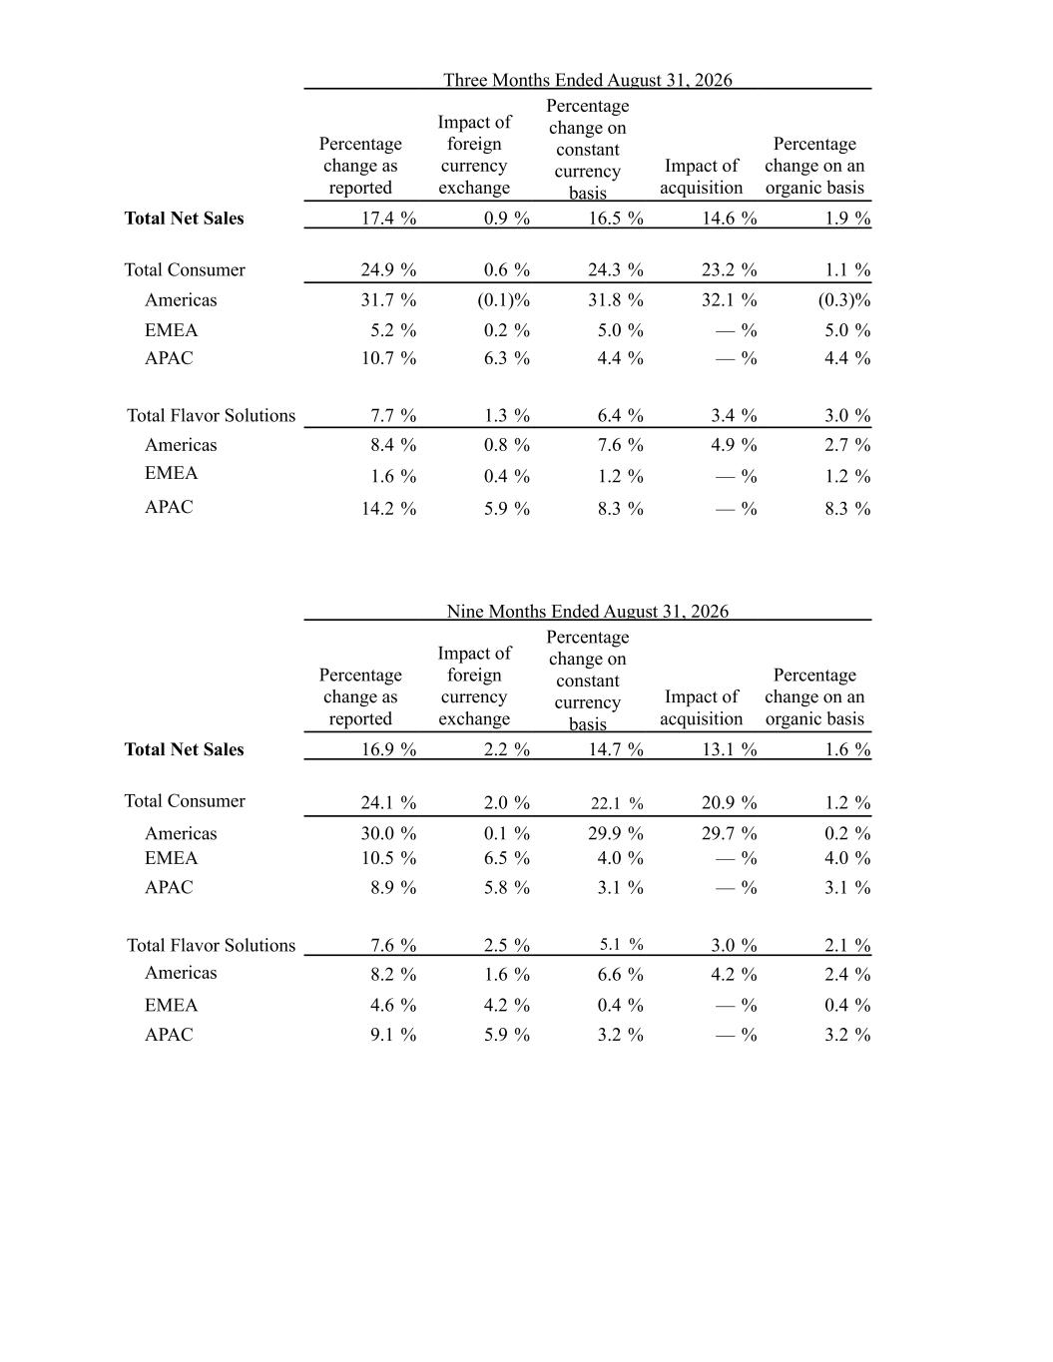
Three Months Ended August 31, 2026 Percentage change as reported Impact of foreign currency exchange Percentage change on constant currency basis Impact of acquisition Percentage change on an organic basis Total Net Sales 17.4 % 0.9 % 16.5 % 14.6 % 1.9 % Total Consumer 24.9 % 0.6 % 24.3 % 23.2 % 1.1 % Americas 31.7 % (0.1) % 31.8 % 32.1 % (0.3) % EMEA 5.2 % 0.2 % 5.0 % — % 5.0 % APAC 10.7 % 6.3 % 4.4 % — % 4.4 % Total Flavor Solutions 7.7 % 1.3 % 6.4 % 3.4 % 3.0 % Americas 8.4 % 0.8 % 7.6 % 4.9 % 2.7 % EMEA 1.6 % 0.4 % 1.2 % — % 1.2 % APAC 14.2 % 5.9 % 8.3 % — % 8.3 % Nine Months Ended August 31, 2026 Percentage change as reported Impact of foreign currency exchange Percentage change on constant currency basis Impact of acquisition Percentage change on an organic basis Total Net Sales 16.9 % 2.2 % 14.7 % 13.1 % 1.6 % Total Consumer 24.1 % 2.0 % 22.1 % 20.9 % 1.2 % Americas 30.0 % 0.1 % 29.9 % 29.7 % 0.2 % EMEA 10.5 % 6.5 % 4.0 % — % 4.0 % APAC 8.9 % 5.8 % 3.1 % — % 3.1 % Total Flavor Solutions 7.6 % 2.5 % 5.1 % 3.0 % 2.1 % Americas 8.2 % 1.6 % 6.6 % 4.2 % 2.4 % EMEA 4.6 % 4.2 % 0.4 % — % 0.4 % APAC 9.1 % 5.9 % 3.2 % — % 3.2 %

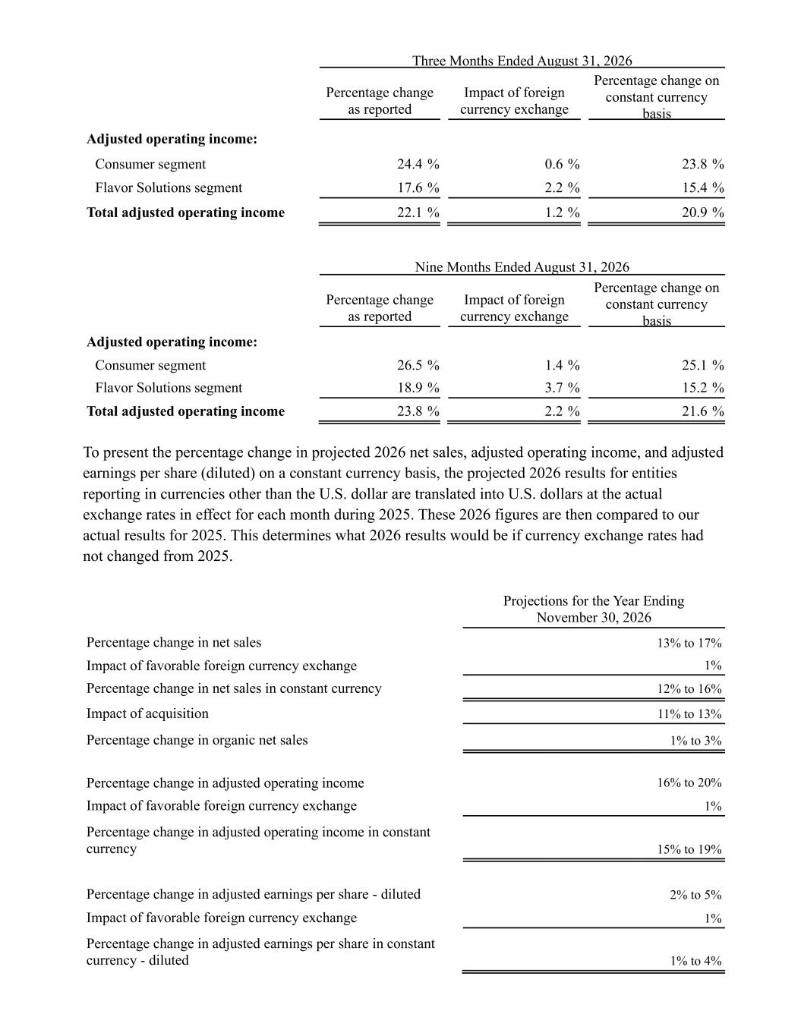
Three Months Ended August 31, 2026 Percentage change as reported Impact of foreign currency exchange Percentage change on constant currency basis Adjusted operating income: Consumer segment 24.4 % 0.6 % 23.8 % Flavor Solutions segment 17.6 % 2.2 % 15.4 % Total adjusted operating income 22.1 % 1.2 % 20.9 % Nine Months Ended August 31, 2026 Percentage change as reported Impact of foreign currency exchange Percentage change on constant currency basis Adjusted operating income: Consumer segment 26.5 % 1.4 % 25.1 % Flavor Solutions segment 18.9 % 3.7 % 15.2 % Total adjusted operating income 23.8 % 2.2 % 21.6 % To present the percentage change in projected 2026 net sales, adjusted operating income, and adjusted earnings per share (diluted) on a constant currency basis, the projected 2026 results for entities reporting in currencies other than the U.S. dollar are translated into U.S. dollars at the actual exchange rates in effect for each month during 2025. These 2026 figures are then compared to our actual results for 2025. This determines what 2026 results would be if currency exchange rates had not changed from 2025. Projections for the Year Ending November 30, 2026 Percentage change in net sales 13% to 17% Impact of favorable foreign currency exchange 1% Percentage change in net sales in constant currency 12% to 16% Impact of acquisition 11% to 13% Percentage change in organic net sales 1% to 3% Percentage change in adjusted operating income 16% to 20% Impact of favorable foreign currency exchange 1% Percentage change in adjusted operating income in constant currency 15% to 19% Percentage change in adjusted earnings per share - diluted 2% to 5% Impact of favorable foreign currency exchange 1% Percentage change in adjusted earnings per share in constant currency - diluted 1% to 4%

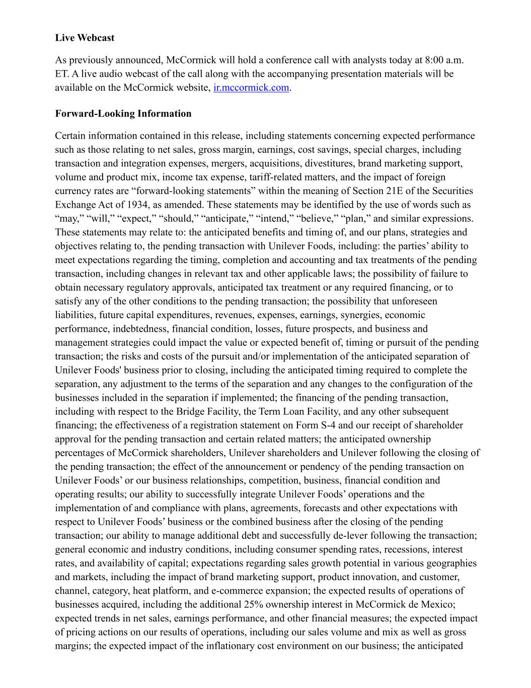
Live Webcast As previously announced, McCormick will hold a conference call with analysts today at 8:00 a.m. ET. A live audio webcast of the call along with the accompanying presentation materials will be available on the McCormick website, ir.mccormick.com. Forward-Looking Information Certain information contained in this release, including statements concerning expected performance such as those relating to net sales, gross margin, earnings, cost savings, special charges, including transaction and integration expenses, mergers, acquisitions, divestitures, brand marketing support, volume and product mix, income tax expense, tariff-related matters, and the impact of foreign currency rates are “forward-looking statements” within the meaning of Section 21E of the Securities Exchange Act of 1934, as amended. These statements may be identified by the use of words such as “may,” “will,” “expect,” “should,” “anticipate,” “intend,” “believe,” “plan,” and similar expressions. These statements may relate to: the anticipated benefits and timing of, and our plans, strategies and objectives relating to, the pending transaction with Unilever Foods, including: the parties’ ability to meet expectations regarding the timing, completion and accounting and tax treatments of the pending transaction, including changes in relevant tax and other applicable laws; the possibility of failure to obtain necessary regulatory approvals, anticipated tax treatment or any required financing, or to satisfy any of the other conditions to the pending transaction; the possibility that unforeseen liabilities, future capital expenditures, revenues, expenses, earnings, synergies, economic performance, indebtedness, financial condition, losses, future prospects, and business and management strategies could impact the value or expected benefit of, timing or pursuit of the pending transaction; the risks and costs of the pursuit and/or implementation of the anticipated separation of Unilever Foods' business prior to closing, including the anticipated timing required to complete the separation, any adjustment to the terms of the separation and any changes to the configuration of the businesses included in the separation if implemented; the financing of the pending transaction, including with respect to the Bridge Facility, the Term Loan Facility, and any other subsequent financing; the effectiveness of a registration statement on Form S-4 and our receipt of shareholder approval for the pending transaction and certain related matters; the anticipated ownership percentages of McCormick shareholders, Unilever shareholders and Unilever following the closing of the pending transaction; the effect of the announcement or pendency of the pending transaction on Unilever Foods’ or our business relationships, competition, business, financial condition and operating results; our ability to successfully integrate Unilever Foods’ operations and the implementation of and compliance with plans, agreements, forecasts and other expectations with respect to Unilever Foods’ business or the combined business after the closing of the pending transaction; our ability to manage additional debt and successfully de-lever following the transaction; general economic and industry conditions, including consumer spending rates, recessions, interest rates, and availability of capital; expectations regarding sales growth potential in various geographies and markets, including the impact of brand marketing support, product innovation, and customer, channel, category, heat platform, and e-commerce expansion; the expected results of operations of businesses acquired, including the additional 25% ownership interest in McCormick de Mexico; expected trends in net sales, earnings performance, and other financial measures; the expected impact of pricing actions on our results of operations, including our sales volume and mix as well as gross margins; the expected impact of the inflationary cost environment on our business; the anticipated

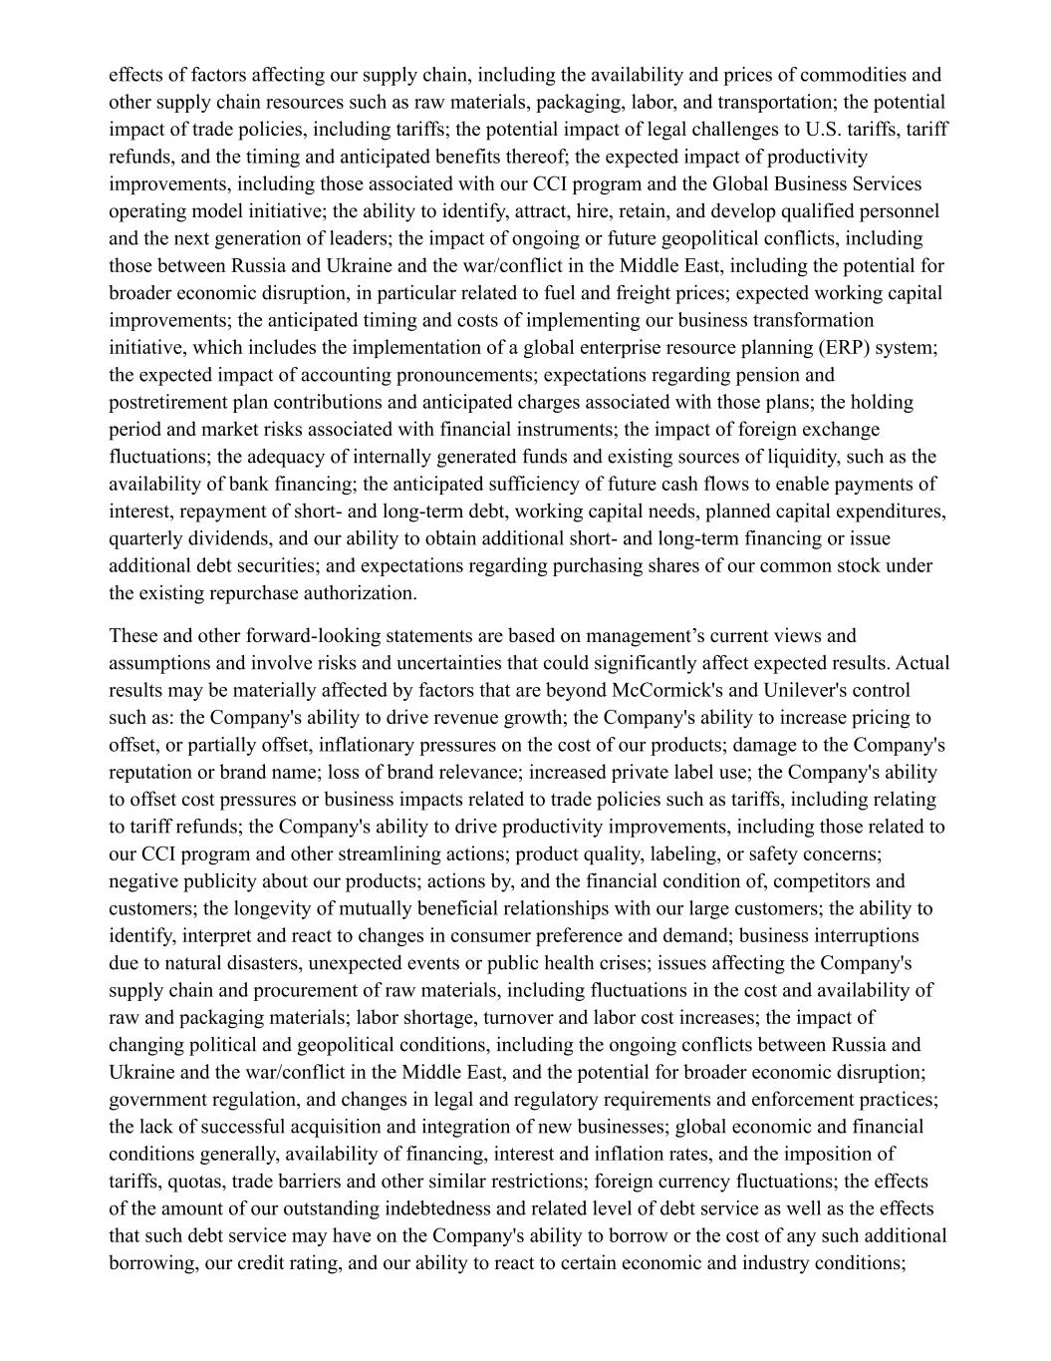
effects of factors affecting our supply chain, including the availability and prices of commodities and other supply chain resources such as raw materials, packaging, labor, and transportation; the potential impact of trade policies, including tariffs; the potential impact of legal challenges to U.S. tariffs, tariff refunds, and the timing and anticipated benefits thereof; the expected impact of productivity improvements, including those associated with our CCI program and the Global Business Services operating model initiative; the ability to identify, attract, hire, retain, and develop qualified personnel and the next generation of leaders; the impact of ongoing or future geopolitical conflicts, including those between Russia and Ukraine and the war/conflict in the Middle East, including the potential for broader economic disruption, in particular related to fuel and freight prices; expected working capital improvements; the anticipated timing and costs of implementing our business transformation initiative, which includes the implementation of a global enterprise resource planning (ERP) system; the expected impact of accounting pronouncements; expectations regarding pension and postretirement plan contributions and anticipated charges associated with those plans; the holding period and market risks associated with financial instruments; the impact of foreign exchange fluctuations; the adequacy of internally generated funds and existing sources of liquidity, such as the availability of bank financing; the anticipated sufficiency of future cash flows to enable payments of interest, repayment of short- and long-term debt, working capital needs, planned capital expenditures, quarterly dividends, and our ability to obtain additional short- and long-term financing or issue additional debt securities; and expectations regarding purchasing shares of our common stock under the existing repurchase authorization. These and other forward-looking statements are based on management’s current views and assumptions and involve risks and uncertainties that could significantly affect expected results. Actual results may be materially affected by factors that are beyond McCormick's and Unilever's control such as: the Company's ability to drive revenue growth; the Company's ability to increase pricing to offset, or partially offset, inflationary pressures on the cost of our products; damage to the Company's reputation or brand name; loss of brand relevance; increased private label use; the Company's ability to offset cost pressures or business impacts related to trade policies such as tariffs, including relating to tariff refunds; the Company's ability to drive productivity improvements, including those related to our CCI program and other streamlining actions; product quality, labeling, or safety concerns; negative publicity about our products; actions by, and the financial condition of, competitors and customers; the longevity of mutually beneficial relationships with our large customers; the ability to identify, interpret and react to changes in consumer preference and demand; business interruptions due to natural disasters, unexpected events or public health crises; issues affecting the Company's supply chain and procurement of raw materials, including fluctuations in the cost and availability of raw and packaging materials; labor shortage, turnover and labor cost increases; the impact of changing political and geopolitical conditions, including the ongoing conflicts between Russia and Ukraine and the war/conflict in the Middle East, and the potential for broader economic disruption; government regulation, and changes in legal and regulatory requirements and enforcement practices; the lack of successful acquisition and integration of new businesses; global economic and financial conditions generally, availability of financing, interest and inflation rates, and the imposition of tariffs, quotas, trade barriers and other similar restrictions; foreign currency fluctuations; the effects of the amount of our outstanding indebtedness and related level of debt service as well as the effects that such debt service may have on the Company's ability to borrow or the cost of any such additional borrowing, our credit rating, and our ability to react to certain economic and industry conditions;

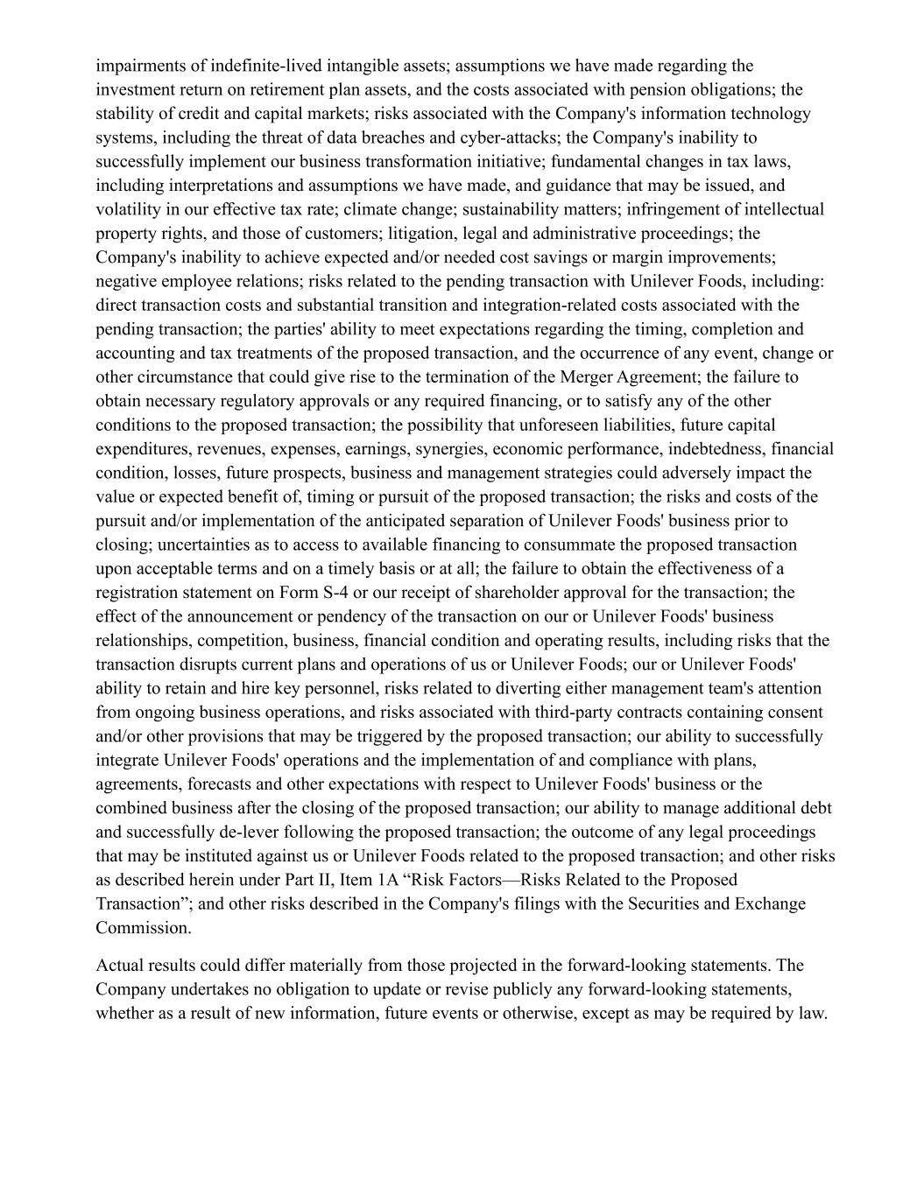
impairments of indefinite-lived intangible assets; assumptions we have made regarding the investment return on retirement plan assets, and the costs associated with pension obligations; the stability of credit and capital markets; risks associated with the Company's information technology systems, including the threat of data breaches and cyber-attacks; the Company's inability to successfully implement our business transformation initiative; fundamental changes in tax laws, including interpretations and assumptions we have made, and guidance that may be issued, and volatility in our effective tax rate; climate change; sustainability matters; infringement of intellectual property rights, and those of customers; litigation, legal and administrative proceedings; the Company's inability to achieve expected and/or needed cost savings or margin improvements; negative employee relations; risks related to the pending transaction with Unilever Foods, including: direct transaction costs and substantial transition and integration-related costs associated with the pending transaction; the parties' ability to meet expectations regarding the timing, completion and accounting and tax treatments of the proposed transaction, and the occurrence of any event, change or other circumstance that could give rise to the termination of the Merger Agreement; the failure to obtain necessary regulatory approvals or any required financing, or to satisfy any of the other conditions to the proposed transaction; the possibility that unforeseen liabilities, future capital expenditures, revenues, expenses, earnings, synergies, economic performance, indebtedness, financial condition, losses, future prospects, business and management strategies could adversely impact the value or expected benefit of, timing or pursuit of the proposed transaction; the risks and costs of the pursuit and/or implementation of the anticipated separation of Unilever Foods' business prior to closing; uncertainties as to access to available financing to consummate the proposed transaction upon acceptable terms and on a timely basis or at all; the failure to obtain the effectiveness of a registration statement on Form S-4 or our receipt of shareholder approval for the transaction; the effect of the announcement or pendency of the transaction on our or Unilever Foods' business relationships, competition, business, financial condition and operating results, including risks that the transaction disrupts current plans and operations of us or Unilever Foods; our or Unilever Foods' ability to retain and hire key personnel, risks related to diverting either management team's attention from ongoing business operations, and risks associated with third-party contracts containing consent and/or other provisions that may be triggered by the proposed transaction; our ability to successfully integrate Unilever Foods' operations and the implementation of and compliance with plans, agreements, forecasts and other expectations with respect to Unilever Foods' business or the combined business after the closing of the proposed transaction; our ability to manage additional debt and successfully de-lever following the proposed transaction; the outcome of any legal proceedings that may be instituted against us or Unilever Foods related to the proposed transaction; and other risks as described herein under Part II, Item 1A “Risk Factors—Risks Related to the Proposed Transaction”; and other risks described in the Company's filings with the Securities and Exchange Commission. Actual results could differ materially from those projected in the forward-looking statements. The Company undertakes no obligation to update or revise publicly any forward-looking statements, whether as a result of new information, future events or otherwise, except as may be required by law.

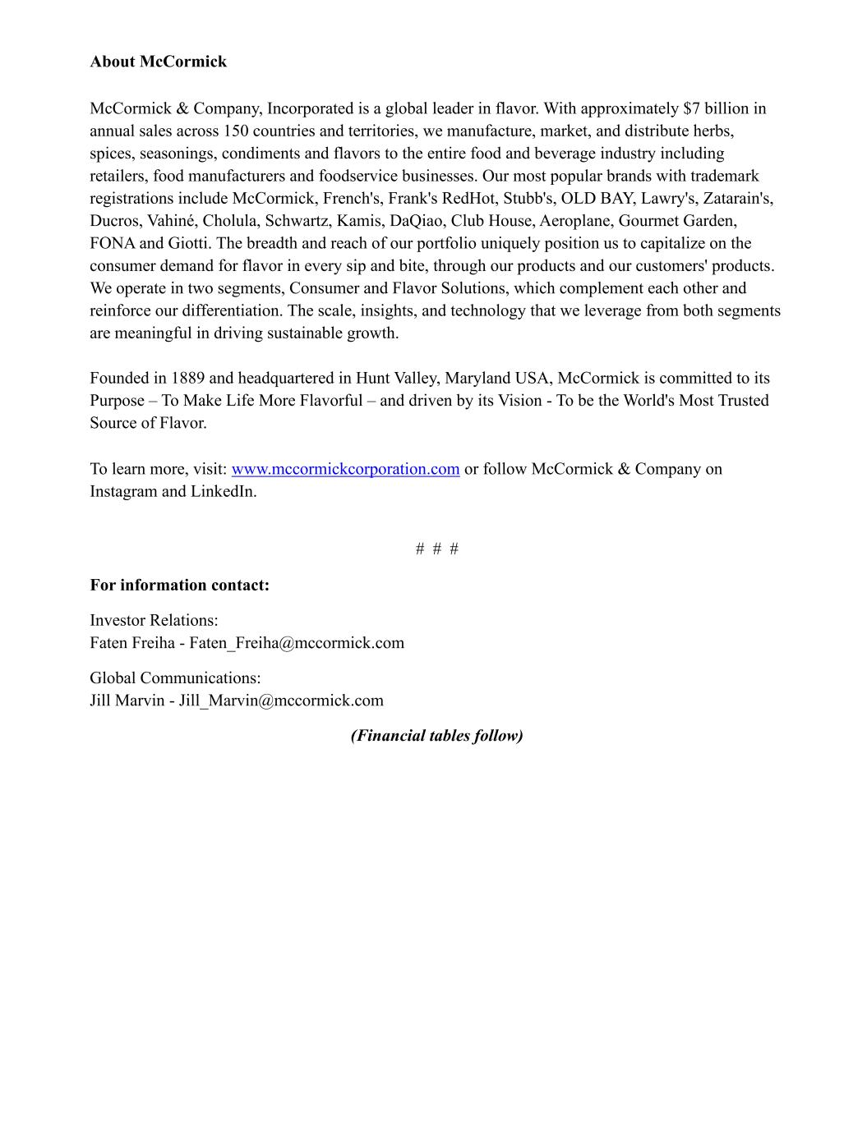
About McCormick McCormick & Company, Incorporated is a global leader in flavor. With approximately $7 billion in annual sales across 150 countries and territories, we manufacture, market, and distribute herbs, spices, seasonings, condiments and flavors to the entire food and beverage industry including retailers, food manufacturers and foodservice businesses. Our most popular brands with trademark registrations include McCormick, French's, Frank's RedHot, Stubb's, OLD BAY, Lawry's, Zatarain's, Ducros, Vahiné, Cholula, Schwartz, Kamis, DaQiao, Club House, Aeroplane, Gourmet Garden, FONA and Giotti. The breadth and reach of our portfolio uniquely position us to capitalize on the consumer demand for flavor in every sip and bite, through our products and our customers' products. We operate in two segments, Consumer and Flavor Solutions, which complement each other and reinforce our differentiation. The scale, insights, and technology that we leverage from both segments are meaningful in driving sustainable growth. Founded in 1889 and headquartered in Hunt Valley, Maryland USA, McCormick is committed to its Purpose – To Make Life More Flavorful – and driven by its Vision - To be the World's Most Trusted Source of Flavor. To learn more, visit: www.mccormickcorporation.com or follow McCormick & Company on Instagram and LinkedIn. # # # For information contact: Investor Relations: Faten Freiha - Faten_Freiha@mccormick.com Global Communications: Jill Marvin - Jill_Marvin@mccormick.com (Financial tables follow)

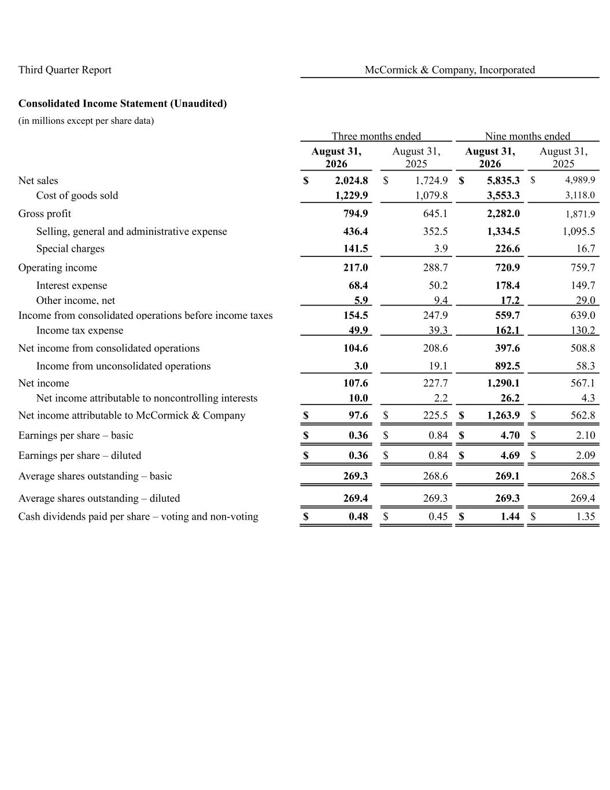
Third Quarter Report McCormick & Company, Incorporated Consolidated Income Statement (Unaudited) (in millions except per share data) Three months ended Nine months ended August 31, 2026 August 31, 2025 August 31, 2026 August 31, 2025 Net sales $ 2,024.8 $ 1,724.9 $ 5,835.3 $ 4,989.9 Cost of goods sold 1,229.9 1,079.8 3,553.3 3,118.0 Gross profit 794.9 645.1 2,282.0 1,871.9 Selling, general and administrative expense 436.4 352.5 1,334.5 1,095.5 Special charges 141.5 3.9 226.6 16.7 Operating income 217.0 288.7 720.9 759.7 Interest expense 68.4 50.2 178.4 149.7 Other income, net 5.9 9.4 17.2 29.0 Income from consolidated operations before income taxes 154.5 247.9 559.7 639.0 Income tax expense 49.9 39.3 162.1 130.2 Net income from consolidated operations 104.6 208.6 397.6 508.8 Income from unconsolidated operations 3.0 19.1 892.5 58.3 Net income 107.6 227.7 1,290.1 567.1 Net income attributable to noncontrolling interests 10.0 2.2 26.2 4.3 Net income attributable to McCormick & Company $ 97.6 $ 225.5 $ 1,263.9 $ 562.8 Earnings per share – basic $ 0.36 $ 0.84 $ 4.70 $ 2.10 Earnings per share – diluted $ 0.36 $ 0.84 $ 4.69 $ 2.09 Average shares outstanding – basic 269.3 268.6 269.1 268.5 Average shares outstanding – diluted 269.4 269.3 269.3 269.4 Cash dividends paid per share – voting and non-voting $ 0.48 $ 0.45 $ 1.44 $ 1.35

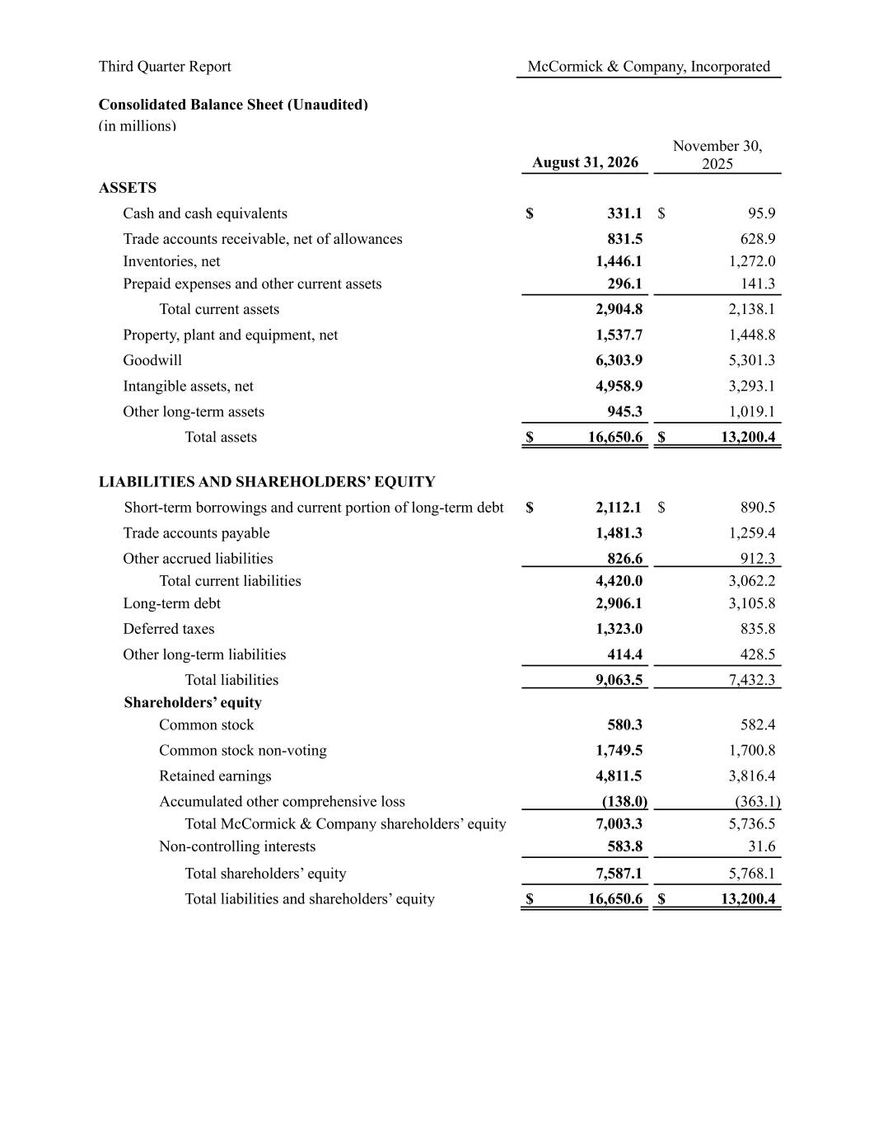
Third Quarter Report McCormick & Company, Incorporated Consolidated Balance Sheet (Unaudited) (in millions) August 31, 2026 November 30, 2025 ASSETS Cash and cash equivalents $ 331.1 $ 95.9 Trade accounts receivable, net of allowances 831.5 628.9 Inventories, net 1,446.1 1,272.0 Prepaid expenses and other current assets 296.1 141.3 Total current assets 2,904.8 2,138.1 Property, plant and equipment, net 1,537.7 1,448.8 Goodwill 6,303.9 5,301.3 Intangible assets, net 4,958.9 3,293.1 Other long-term assets 945.3 1,019.1 Total assets $ 16,650.6 $ 13,200.4 LIABILITIES AND SHAREHOLDERS’ EQUITY Short-term borrowings and current portion of long-term debt $ 2,112.1 $ 890.5 Trade accounts payable 1,481.3 1,259.4 Other accrued liabilities 826.6 912.3 Total current liabilities 4,420.0 3,062.2 Long-term debt 2,906.1 3,105.8 Deferred taxes 1,323.0 835.8 Other long-term liabilities 414.4 428.5 Total liabilities 9,063.5 7,432.3 Shareholders’ equity Common stock 580.3 582.4 Common stock non-voting 1,749.5 1,700.8 Retained earnings 4,811.5 3,816.4 Accumulated other comprehensive loss (138.0) (363.1) Total McCormick & Company shareholders’ equity 7,003.3 5,736.5 Non-controlling interests 583.8 31.6 Total shareholders’ equity 7,587.1 5,768.1 Total liabilities and shareholders’ equity $ 16,650.6 $ 13,200.4

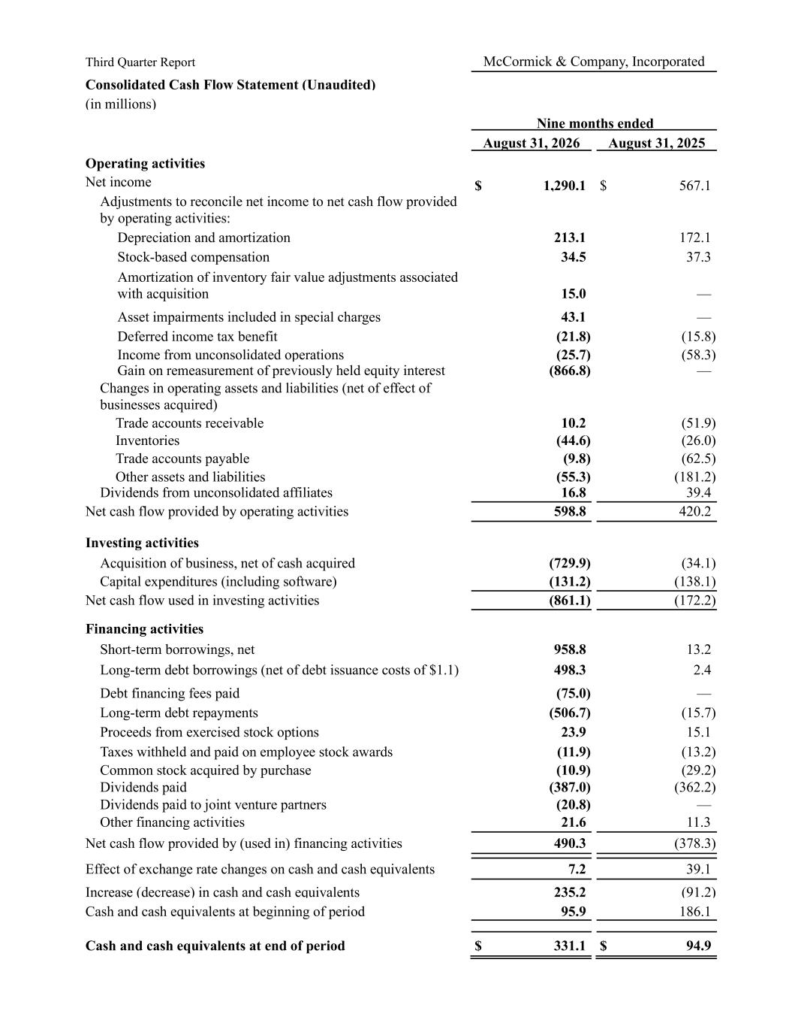
Third Quarter Report McCormick & Company, Incorporated Consolidated Cash Flow Statement (Unaudited) (in millions) Nine months ended August 31, 2026 August 31, 2025 Operating activities Net income $ 1,290.1 $ 567.1 Adjustments to reconcile net income to net cash flow provided by operating activities: Depreciation and amortization 213.1 172.1 Stock-based compensation 34.5 37.3 Amortization of inventory fair value adjustments associated with acquisition 15.0 — Asset impairments included in special charges 43.1 — Deferred income tax benefit (21.8) (15.8) Income from unconsolidated operations (25.7) (58.3) Gain on remeasurement of previously held equity interest (866.8) — Changes in operating assets and liabilities (net of effect of businesses acquired) Trade accounts receivable 10.2 (51.9) Inventories (44.6) (26.0) Trade accounts payable (9.8) (62.5) Other assets and liabilities (55.3) (181.2) Dividends from unconsolidated affiliates 16.8 39.4 Net cash flow provided by operating activities 598.8 420.2 Investing activities Acquisition of business, net of cash acquired (729.9) (34.1) Capital expenditures (including software) (131.2) (138.1) Net cash flow used in investing activities (861.1) (172.2) Financing activities Short-term borrowings, net 958.8 13.2 Long-term debt borrowings (net of debt issuance costs of $1.1) 498.3 2.4 Debt financing fees paid (75.0) — Long-term debt repayments (506.7) (15.7) Proceeds from exercised stock options 23.9 15.1 Taxes withheld and paid on employee stock awards (11.9) (13.2) Common stock acquired by purchase (10.9) (29.2) Dividends paid (387.0) (362.2) Dividends paid to joint venture partners (20.8) — Other financing activities 21.6 11.3 Net cash flow provided by (used in) financing activities 490.3 (378.3) Effect of exchange rate changes on cash and cash equivalents 7.2 39.1 Increase (decrease) in cash and cash equivalents 235.2 (91.2) Cash and cash equivalents at beginning of period 95.9 186.1 Cash and cash equivalents at end of period $ 331.1 $ 94.9

